**SPH3U 12.6 The Direct Current Motor**

1. **Split ring commutator**

|  |  |
| --- | --- |
| Continuous motion: |  |
| galvanometer |  |

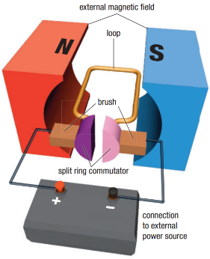

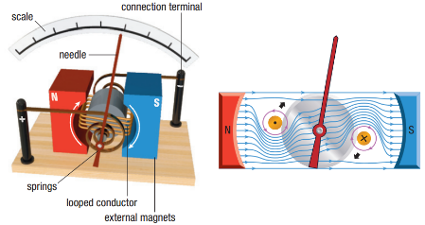

|  |  |
| --- | --- |
| Split ring commutator: |  |

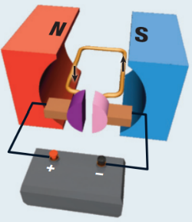 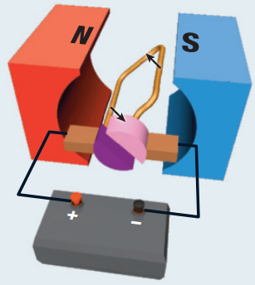 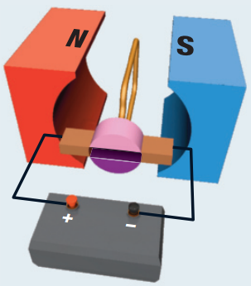 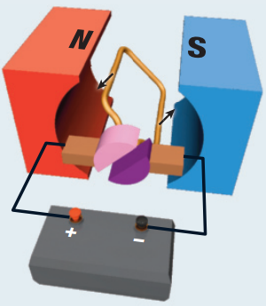

1. **Modern DC motors**

|  |  |
| --- | --- |
| Armature DC motor: |  |
| Modern DC motors: |  |

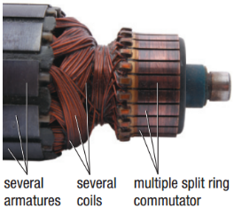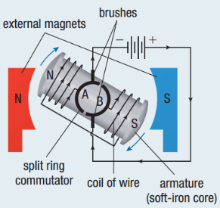 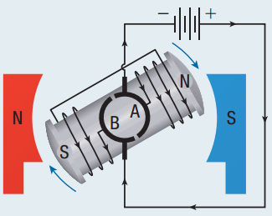 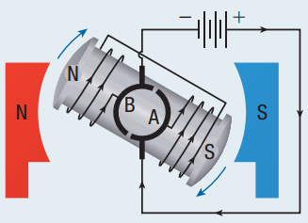

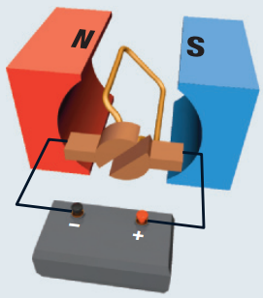In which direction will the following loop rotate? What is the purpose of the split ring commutator?

**Homework:** page 571: #1-3